openIDL - Local Reference Implementation

The local reference implementation (LRI) is useful for kicking the tires and other testing of the openIDL system. It is a fully contained openIDL network with three nodes: AAIS, Carrier and Analytics.

# Quick Start

To get going quickly with the LRI you will need an identity provider. At present, this is cognito. See the section on setting up cognito below.

Once your identity provider is in place, you can follow the startup instructions in the README.md file inside the *openidl-local-reference-implementation* folder in the openidl-main project from github. You can get that here: <https://github.com/openidl-org/openidl-main>

The branch to use is: ??

## Setup Cognito for Reference Implementation

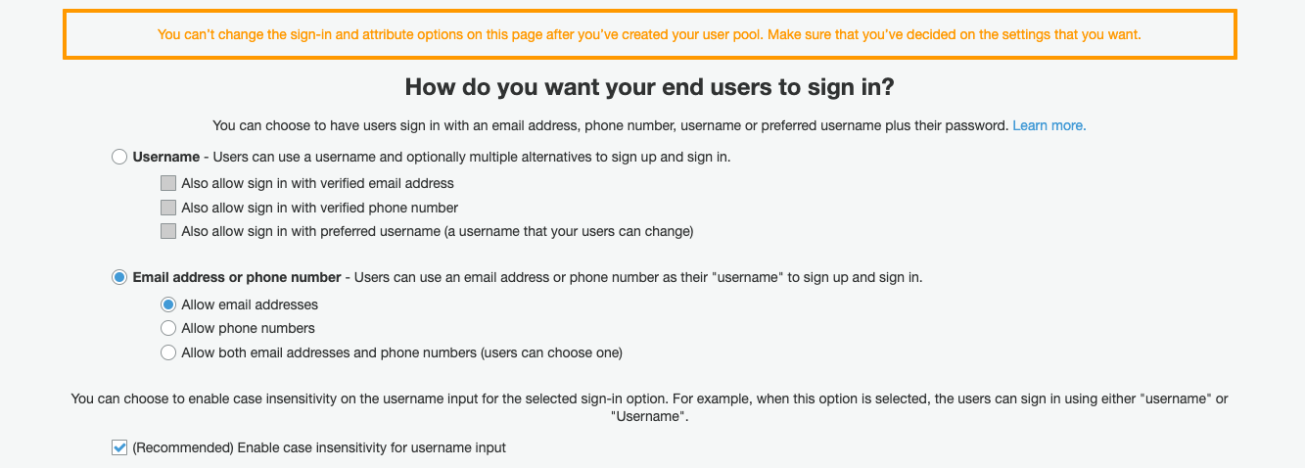

NOTE: the “custom:” is added by aws. When updating, do not include this.

add the client after or you will lose your user pool.

### Add and App Client

### App Client Settings

Choose the domain

Open the hosted ui from the app client settings page.

change the password

Password is Admin@blockchain1